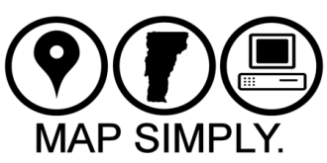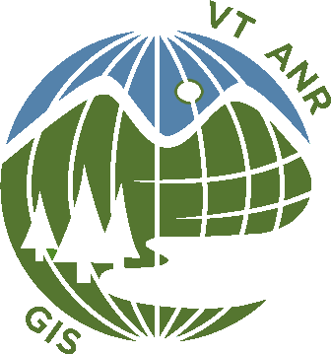
What Is Map Simply?
- Map Simply is about using maps more effectively, more readily, more often.
- Map Simply is about getting more information from our Agency data by improving access and analysis through intuitive map products via web and mobile technologies.
- Map Simply is about visualizing and analyzing environmental relationships. Much of what the Agency manages, monitors, measures, and regulates can be tied to a location. Map Simply enables us to better examine the relationship between these locations.
- Map Simply makes us more powerful and effective environmental communicators with our constituents by leveraging maps to better articulate environmental science, planning, policy and management decisions.
- Map Simply is about getting more out of our geographic information technology investments by putting appropriate mapping technologies into Agency staff hands and the public so that they can better exploit geospatial data and information.
ANR GIS has created the Map Simply strategy to increase our mapping products and services through web, mobile and cloud computing technologies; increase the utility of our Agency data by geo-enabling it; increase the accessibility to Agency data and documents through intuitive map searches; and increase our return on our ArcGIS software investments by putting appropriate mapping technologies into your hands.
With the upgrade and reconfiguration of our GIS enterprise server environment and the launch of a new web and mobile mapping platform, ANR GIS is poised to release powerful, easier-to-use, intuitive map services. The first two major releases are the ANR Atlas and BioFinder. The ANR Atlas has been mobile-enabled on smartphones through the ArcGIS app.
What does this mean to you? ANR GIS will expand web-based map applications and tools to meet your and the public’s mapping requirements that are far easier to use than ArcGIS desktop software. ANR GIS will seek opportunities to expose your data through maps. ANR GIS will expand our mobile offerings to put maps at your fingertips in the field and Agency data into an increasingly mobile public.
Stay tuned for more information on our Map Simply Strategy!
Thank you,
The ANR GIS Team

